**Taylor Anderson** was an extraordinary American who dedicated herself to teaching Japanese children, living her dream right up to the events of March 11, 2011.

Taylor was the first confirmed American casualty of the Great East Japan Earthquake and Tsunami. She was last seen helping and assuring her students after the disaster.

Join us to commemorate the 4th anniversary of the Great East Japan Earthquake and Tsunami, and to witness Taylor's life as she shared her passion with fellow young Americans living in Japan.

**More information visit** [**www.jas-socal.org**](http://www.jas-socal.org)

LIVE YOUR DREAM THE TAYLOR ANDERSON STORY

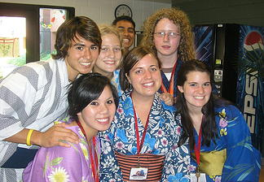

**Sun, Mar 8 - 5:15pm** @ JANM (Little Tokyo)  
*Part of Love To Nippon   
 3.11 Memorial Event*

**Wed, Mar 11 - 7:00pm** @ The Japan Foundation  
(Miracle Mile, Los Angeles)

***FREE ADMISSION***